
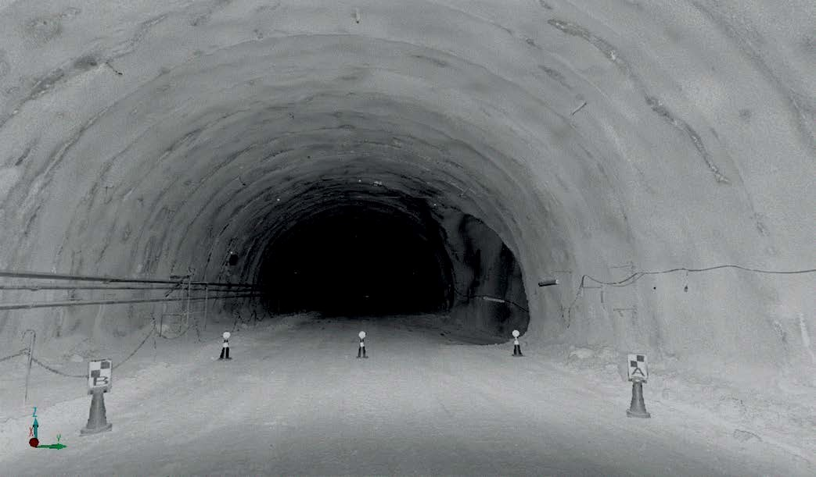

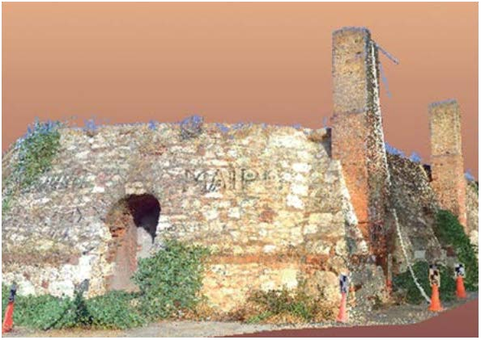
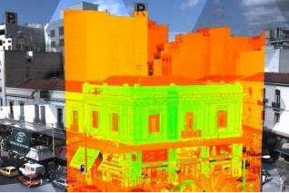
www.aksm.gr
LASER SCANNING & BIM
BENEFITS
- Improved – communication, collaboration
- & transparency
- Lower – overall costs on build
- Reliable – quality checked data (model against scan)
- Faster – decision making, implementation of project alterations
- Less – time on site, missed data, rework, construction clashes
- Fewer – errors & costly mistakes, plan virtually
- Phased – scan & model parts of the project when & if required
- Better – sustainability, using BIM throughout the building’s life.
- ‘What if’ – plans & sequences can be optimized virtually
DELIVERABLES

• 3D laser scan point cloud
• Leica TruView dataset – accessed via web browser
• 3D intelligent BIM model
• Rendered visualizations & flythroughs
• Topographical survey of surrounding area
• 2D floor plans, elevations & sections (from
BIM model)
• 3D PDFs – accessed via Adobe’s free
Reader software
9
LASER SCANNING & BIM
Surveying Precision

BENEFITS

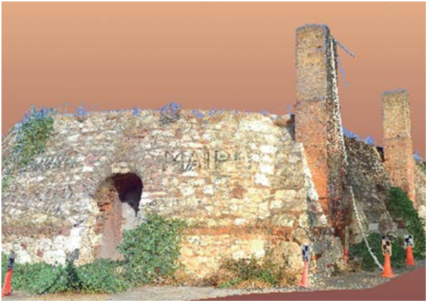
• Improved – communication, collaboration
& transparency
• Lower – overall costs on build
• Reliable – quality checked data (model against scan)
• Faster – decision making, implementation of project alterations
• Less – time on site, missed data, rework, construction clashes
• Fewer – errors & costly mistakes, plan virtually
• Phased – scan & model parts of the
project when & if required
• Better – sustainability, using BIM throughout the building’s life.
• ‘What if’ – plans & sequences can be optimized virtually
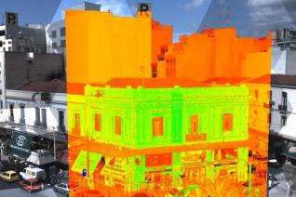

DELIVERABLES

• 3D laser scan point cloud
• Leica TruView dataset – accessed via web browser
• 3D intelligent BIM model
• Rendered visualizations & flythroughs
• Topographical survey of surrounding area
• 2D floor plans, elevations & sections (from
BIM model)
• 3D PDFs – accessed via Adobe’s free
Reader software
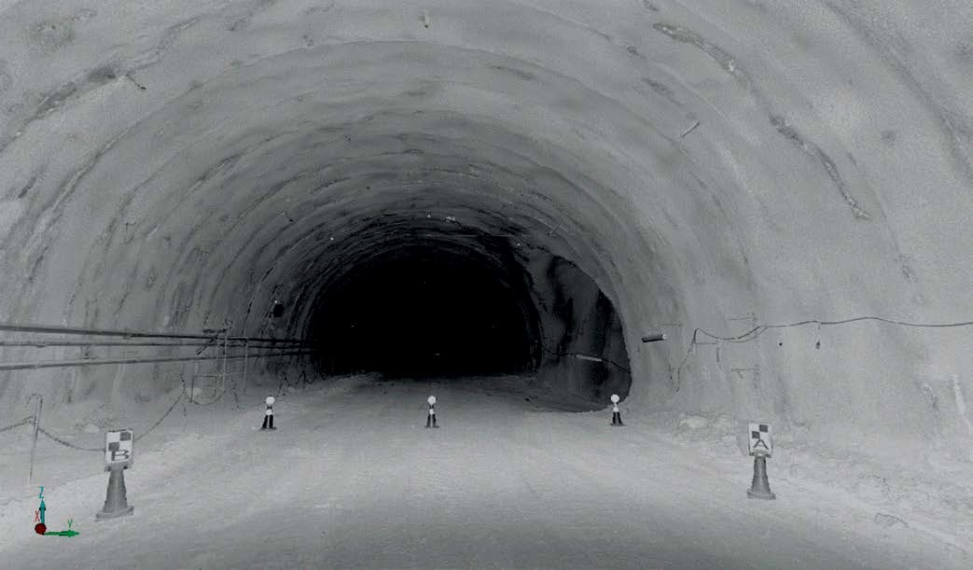

8

